MEGHNAD SAHA INSTITUTE OF TECHNOLOGY

*Techno Complex, Madurdaha,Beside NRI Complex, Post-Uchhepota, Kolkata 700 150*

LABORATORY NOTE BOOK

MAKAUT ODD SEMESTER 2024



[MASTERS OF COMPUTER APPLICATION]

[RELATIONAL DATABASE MANAGEMENT SYSTEM LAB (MCAN192)]

[RUPAK SARKAR]

ROLL NO: REGN. NO.:

STREAM: MCA SEMESTER: I (1ST)

YEAR: 1ST YearSESSION: 2024-2026



MAULANA ABUL KALAM AZAD UNIVERSITY OF TECHNOLOGY



MEGHNAD SAHA INSTITUTE OF TECHNOLOGY

*Techno Complex,. Madurdaha,Beside NRI Complex, Post-Uchhepota, Kolkata 700 150*

“LIST OF ASSIGNMENT/EXPERIMENT SUBMISSION DETAILS”

|  |  |  |  |  |  |
| --- | --- | --- | --- | --- | --- |
| **SL.**  **NO.** | **ASSIGNMENT / EXPERIMENT NAME** | **PLANNED DATE OF SUBMISSION** | **ACTUAL DATE OF SUBMISION** | **CHECKED BY** | **REMARKS (ANY DEVIATION REGARDING SUBMISSION DATES, CONTENT, FORMAT, ETC)** |
| 1. | Create a table with name EMPLOYEE. | 07/11/2024 | 11/11/2024 |  |  |
| 2. | Add new column HIREDATE. | 07/11/2024 | 11/11/2024 |  |  |
| 3. | Change datatype of Job_id to varchar2. | 07/11/2024 | 11/11/2024 |  |  |
| 4. | Change the name of Emp_no to E_no. | 07/11/2024 | 11/11/2024 |  |  |
| 5. | Modify column width of job field of EMP table. | 07/11/2024 | 11/11/2024 |  |  |
|  |  |  |  |  |  |
|  |  |  |  |  |  |
|  |  |  |  |  |  |
|  |  |  |  |  |  |
|  |  |  |  |  |  |

|  |
| --- |
| OBSERVATIONS / COMMENTS ON THE OVERALL PERFORMANCE: |

Signature in full with date Signature in full with date

**Faculty / Technical Assistant Lab Examiner**

**Q.1 Create a table EMPLOYEE with following schema:**

**(Emp_no, E_name, E_address, E_ph_no, Dept_no, Dept_name, Job_id, Salary)**

Ans: To create a Table named EMPLOYEE with the given attributes, we write the following command –

**SQL Query –** CREATE TABLE EMPLOYEE(EMP_NO NUMBER(3), E_NAME CHAR(10), E_ADDRESS VARCHAR2(30), E_PH_NO NUMBER(10), DEPT_NO NUMBER(3), DEPT_NAME CHAR(10), JOB_ID CHAR(5), SALARY NUMBER(10));

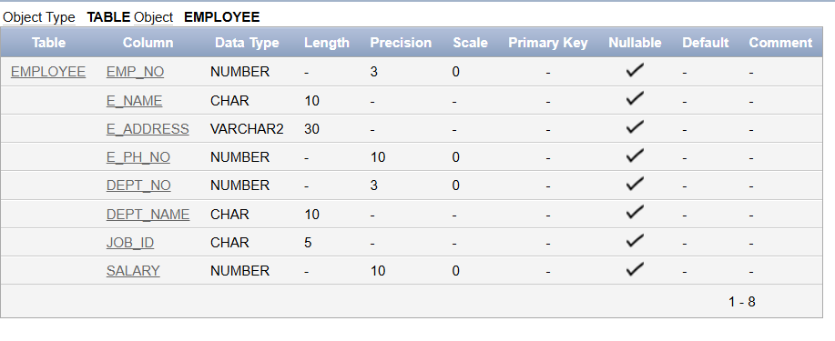

**Q.2 Add a new column HIREDATE to the existing relation.**

Ans: To add a new column names HIREDATE to the schema we write the following command.

**SQL Query –** ALTER TABLE EMPLOYEE ADD(HIREDATE DATE);

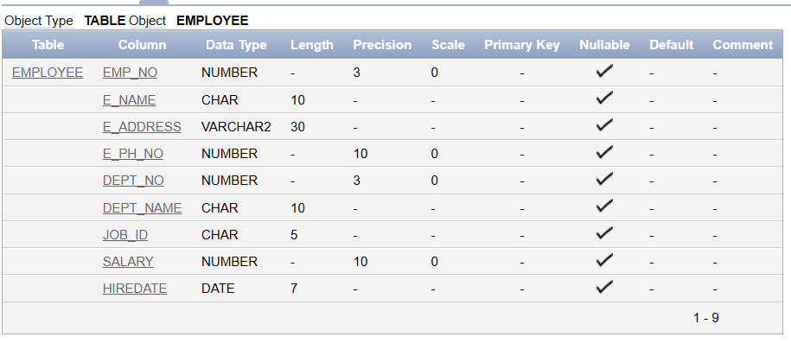  
In the above screenshot, we can see that the column named HIREDATE has been added as the last column of the table.

**Q.3 Change the datatype of Job_id from char to varchar2.**

Ans: To change the datatype of a column from char to varchar2, we write the following query.

**SQL Query –** ALTER TABLE EMPLOYEE MODIFY(JOB_ID VARCHAR2(8));

This query changes the datatype of Job_id from char to varchar2.

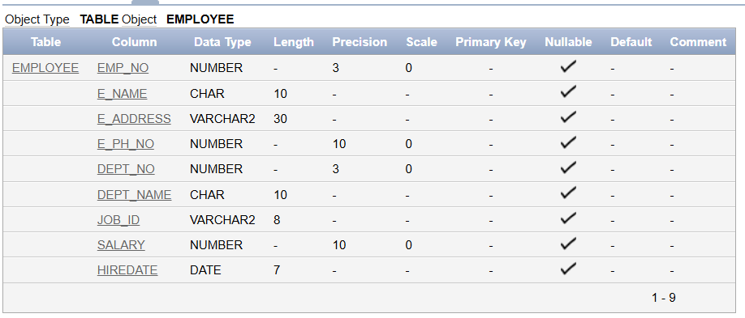

**Q.4 Change the name of column/field Emp_no to E_no.**

Ans: To change the name of a column or field in a database table, we need to write the following query.

**SQL Query –** ALTER TABLE EMPLOYEE RENAME COLUMN EMP_NO TO E_NO;

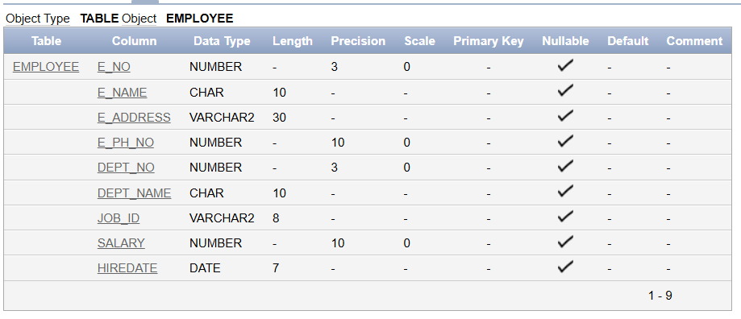

In the above screenshot, we can see that the column name of Emp_no has been changed to E_no.

**Q.5 Modify the column width of the job field of the EMPLOYEE table.**

Ans: For this question, we have added a new field in the database table in the name of Designation and we will then change the column width of this field.

**SQL Query for Designation column –** ALTER TABLE EMPLOYEE ADD(DESIGNATION CHAR(5));

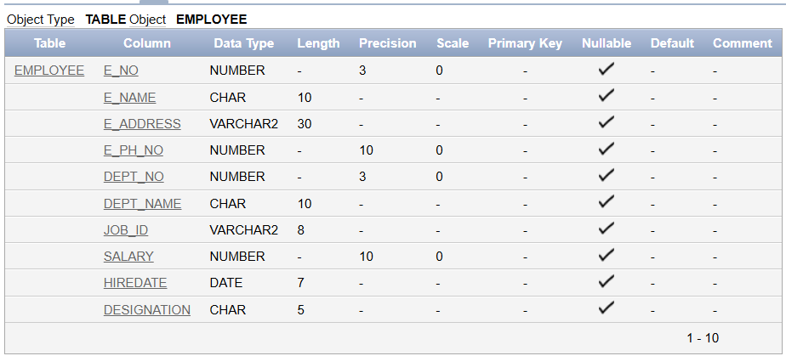

Now, we will change the column width of the Designation field of the table.

**SQL Query –** ALTER TABLE EMPLOYEE MODIFY(DESIGNATION CHAR(10));

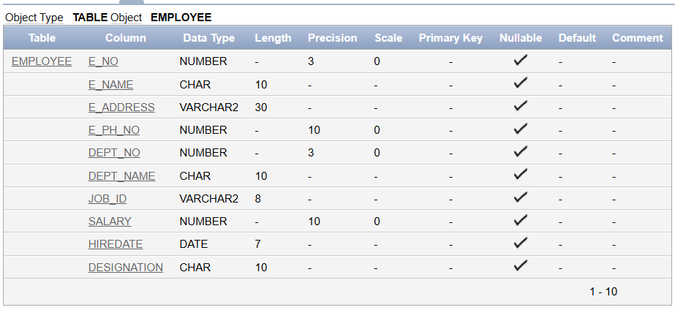

In the above screenshot, the width of Designation has been changed from char(5) to char(10).